LAB EXPERIMENTS

NAME: K. DEVI POOJITHA
REG.NO:192565052
6.Write the python program for Cript-Arithmetic problem

Program:
from itertools import permutations
for p in permutations(range(10), 8): s,e,n,d,m,o,r,y = p
if s == 0 or m == 0: continue
send = 1000*s+100*e+10*n+d more = 1000*m+100*o+10*r+e
money = 10000*m+1000*o+100*n+10*e+y if send+more == money:
print("SEND =", send) print("MORE =", more) print("MONEY =", money) break
Output:
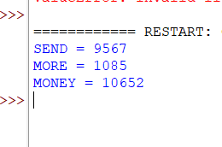
- Write the python program for Vacuum Cleaner problem

Program:
room = {'A': 'Dirty', 'B': 'Dirty'}

location = 'A'

while 'Dirty' in room.values(): print("Location:", location) if room[location] == 'Dirty':
room[location] = 'Clean' print(location, "cleaned")
else:
location = 'B' if location == 'A' else 'A'

print("All rooms are clean") Output:
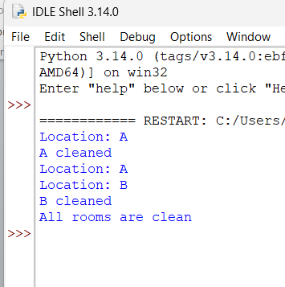
- Write the python program to implement BFS.

Program:
graph = {
'A': ['B', 'C'],
'B': ['D', 'E'],
'C': ['F'],

'D': [],
'E': [],
'F': []
}

visited = [] queue = ['A']

while queue:
node = queue.pop(0) if node not in visited:
print(node, end=" ") visited.append(node) queue.extend(graph[node])
Output:
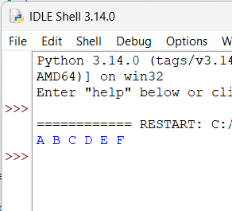
- Write the python program to implement DFS.

Program:
graph = {
'A': ['B', 'C'],
'B': ['D', 'E'],

'C': ['F'],
'D': [],
'E': [],
'F': []
}

visited = set()

def dfs(node):
if node not in visited: print(node, end=" ") visited.add(node) for i in graph[node]:
dfs(i)

dfs('A') Output:
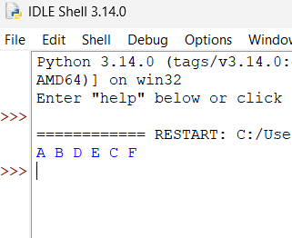
- Write the python program to implement A* algorithm

Program:
graph = {

'A': [('B', 1), ('C', 3)],
'B': [('D', 1), ('E', 5)],
'C': [('F', 2)],
'D': [], 'E': [], 'F': []
}

h = {'A': 4, 'B': 3, 'C': 2, 'D': 0, 'E': 1, 'F': 0}

open_list = [(h['A'], 0, 'A', ['A'])]

while open_list: open_list.sort()
f, g, node, path = open_list.pop(0)

if node == 'D': print("Path:", path)
print("Cost:", g) break

for next_node, cost in graph[node]: new_g = g + cost
open_list.append((new_g + h[next_node], new_g, next_node, path + [next_node]))
Output:

